**Federizer**

**Digital Media Cargo**

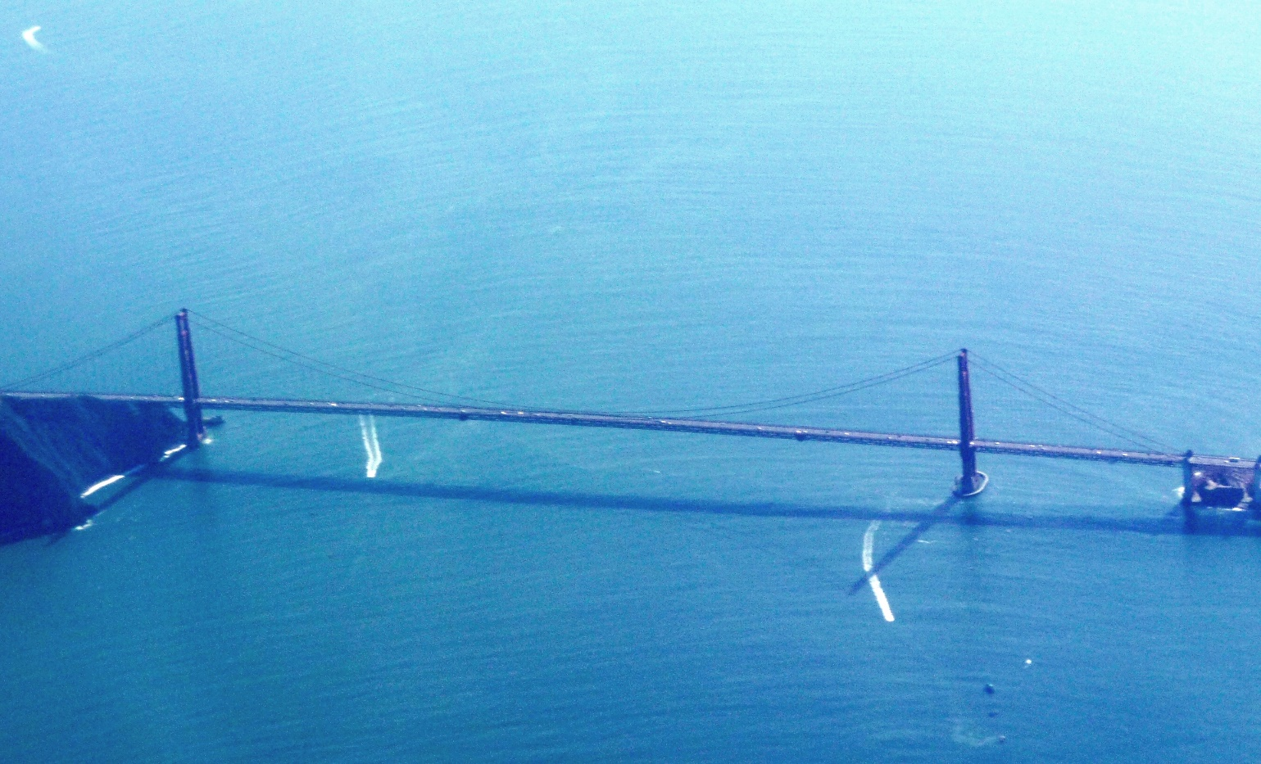

**Abstract**

Federizer is a digital media exchange and storage system analogous to cargo services. People can use Federizer if they need to transfer and store something that is either bulky or large in numbers. This includes documents, images, audios and videos, otherwise Federizer can be used in a similar way as the traditional email system.

**Introduction**

The main components of the email system have been designed between 1971 and 1992 by many inventors. In the course of time, email has become the most commonly used application of the Internet. Nowadays the email infrastructure forms the backbone of the worldwide digital identity, and email is the only truly decentralized communication system of the Internet.

**Problem**

Despite the rising importance of email infrastructure, the whole ecosystem still relies on over 40 year-old architecture and protocol design. There are spam and attachment issues from the very beginning. Even though the main email system vendors and service providers claim email accounts to be safe, the fact remains that major security and functional flaws are not fixed. The email system, while conceptually sound as a communication means, is structurally obsolete and functionally deficient.

**Solution**

This solution adopts the cloud-native approach that aligns with emerging and future business needs. The design model incorporates Privacy by Design principles to maintain the appropriate level of regulatory compliance. The reactive email system concept is built on top of globally distributed Domain Name System, Web technologies and loosely coupled Domain Authentication Layer. The Domain Authentication Layer is built around OAuth 2.0 specification and includes Resource Protection Gateway in order to control information exchange between security domains. The messages and attachments are stored separately in the content repository and likewise, the content is transferred separately. Repository uses a ~~virtual file system~~ and data are transferred using ~~JMAP and SMTP over~~ gRPC/Protocol Buffers system. Documents are stored on disk or S3 compatible object storage and transferred using HTTP/2 protocol.

**Architecture**

Generic Model OAuth2 Model

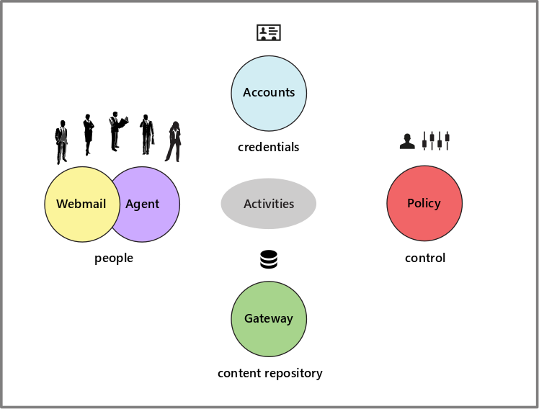 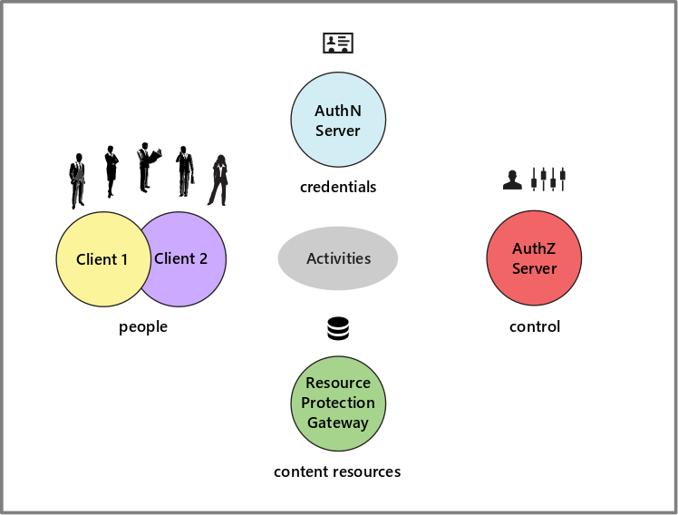

**Proposed Services**

1. Email services
   1. No spam – user invitation/subscription system guaranties no spam in the Inbox
   2. Mail tracking & proof of delivery – similar to registered/certified mail with revocable consent
   3. Reference numbers – channels, threaded conversations
   4. Time management – calendaring, events, to-do, reminders, etc.
   5. No attachments size limit – attachments are transferred separately without size limit
   6. Attachments versioning – attachments with the same content are versioned
   7. Attachment properties – e.g. invoice due date, total due, variable symbol, status
   8. Public/Private Tags – linking/grouping across the business
   9. Instant messages – deliver messages within seconds
   10. Instant attachments – download attachments even before they are actually delivered
   11. Security – easy integration with antivirus and antimalware protection systems
   12. Privacy – distributed nature of Federizer has intrinsic privacy-preserving properties
2. Banking services
   1. Internet payments – make payments directly within the Federizer application
   2. Multi-bank information – overview of all account information consolidated in one place
3. Real-time communication services
   1. Document collaboration – share document with people and edit it together in real-time
   2. Video conferencing, direct file transfer, voice, chat – context-aware communication
4. Dynamic content services

Workflow, document/forms automation, HTML/SVG forms – dynamic and interactive content, EDI transactions

1. Internet of things services …

**Apps**

The Progressive Web Application (PWA) technology is recommended for front-end client development. PWAs are easy to install and allow users to utilize the Federizer system to its full potential.

**New Features**

1. Bulky or large in numbers attachments
2. Tagging system
3. Groups/Channels (mailing lists)
4. No email spoofing
5. Integrations with external systems (API)
6. Cloud-native architecture
7. Digital archive

**Drawback**

Incompatibility with traditional email system .

**Tagline**

Digital Media Cargo.

**Numeronym**

f7r

**Use Cases not covered by the current email system**

1. Basic use case – centralized content repository, exchange digital assets; plan, execute and track (business) activities.
2. Manufacturing/Engineering – product design and development, store and exchange product specifications.
3. Legal – contracts and proposals creation, store and exchange contracts.
4. Digital Media – store and exchange rich media.
5. Sales & Marketing – track sales and marketing activities, store and exchange digital assets.

**Target Market**

According to the 2017 study from the Radicati Group, the number of worldwide email users, including both business and consumer users, will grow from over 3.7 billion in 2017 to over 4.1 billion by 2021. Email use continues to grow in the business world where it is often used not only simply as an interpersonal communication tool, but also as the default choice to send files. That is a lot of B2B and B2C relationships to generate leads to grow the business.

**Competitive Trends**

Although instant messaging, social networking, chat, and enterprise file sharing and synchronization systems are seeing strong adoption, centralized systems are not very acceptable solutions for B2B and B2C communication. Missing Identity and Access Management integration on both communication sides can lead to potential privacy issues such as leakage of intellectual property or loss of confidential content and makes these systems incompatible with enterprise security policies.

**Competitive Advantage**

Transparency and unambiguous data ownership - data are transferred not shared. Ease of use - everyone who uses a computer knows how to use email client, there is no need for Federizer users to take a training course.

**Unfair Advantage**

Intellectual property rights of the Specification Lead / Working Group.

**Business Model**

Federizer is an open source software:

1. Offer a range of support plans to help organizations to use Federizer as a secure and reliable communication platform.
2. Offer custom integrations and consultations for a fee.
3. There is an opportunity to build a business model on global and/or regional Federizer services à la Gmail.
4. Cloud provider partnerships.

**Promotion**

To highlight the underlying difference between email and Federizer use the Cargo Services analogy. Endorse the Federizer term.

**Marketing and Sales**

Partners, Network effect / Word of mouth.

**Market Opportunities**

1. Enterprises
2. Associations
3. Providers
4. Universities

**Project Status**

Major idea iterations completed, system and software architecture within a few prototypes internally tested.

**Strategic Partnership**

Build a strategic relationship with the open minded digital media company to ensure alignment of visions, goals and objectives, and to drive product adoption.

**Exit**

Linux Foundation

**Conclusion**

Federizer can play an important role in communication across various industries in the public and private sectors. The combination of repository, communication and identity represents a single point of information throughout any organization, and symbolizes a gold mine of information for any individual. The Cargo Services analogy predestine Federizer to become more than a traditional email system alternative.